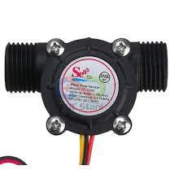

Sensor Waterflow YF-S201

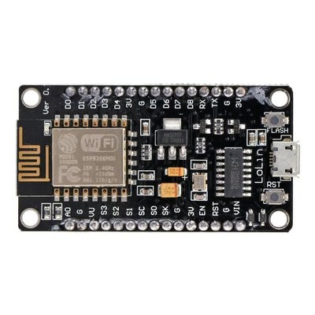

ESP8266 V3 LOLIN

Adaptor/Power Supply

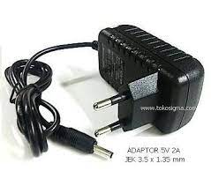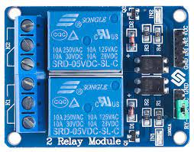

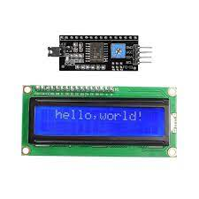

LCD 16x2 dan I2C

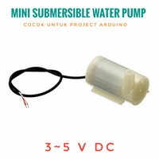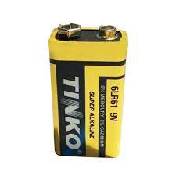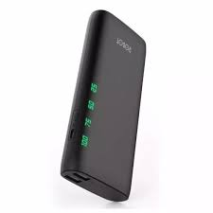

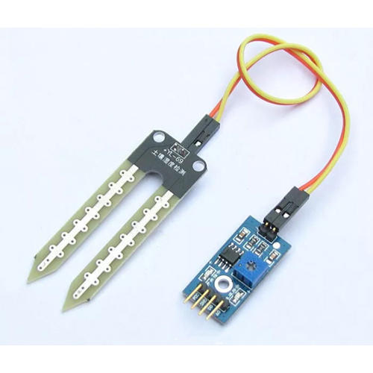

Relay

Power bank/Power Supply

Sensor Soil Moisture

Pompa Air 3-5 VDC

Baterai 9v

|  |  |  |
| --- | --- | --- |
| Device | Port Device | Port ESP8266 |
| Sensor Soil Moisture | VCC | 3v3 |
|  | GND | GND |
|  | A0 | A0 |
| Relay | VCC | 3v3 |
|  | GND | GND |
|  | IN | D4 |
| LCD 16X2 dan I2C | VCC | VU |
|  | GND | GND |
|  | SDA | D2 |
|  | SCL | D1 |
| Sensor Waterflow YF-S201 | Black wire | GND |
|  | Red wire | VIN |
|  | Yellow wire | D5 |